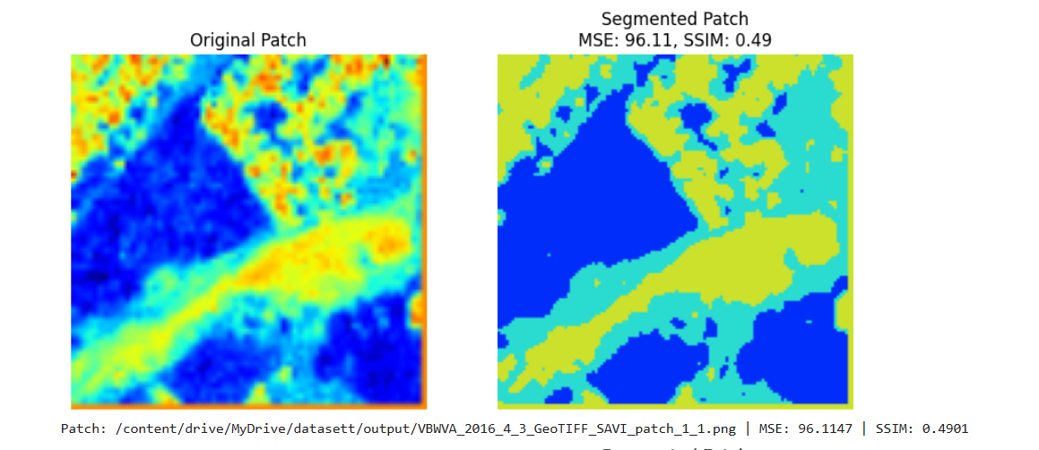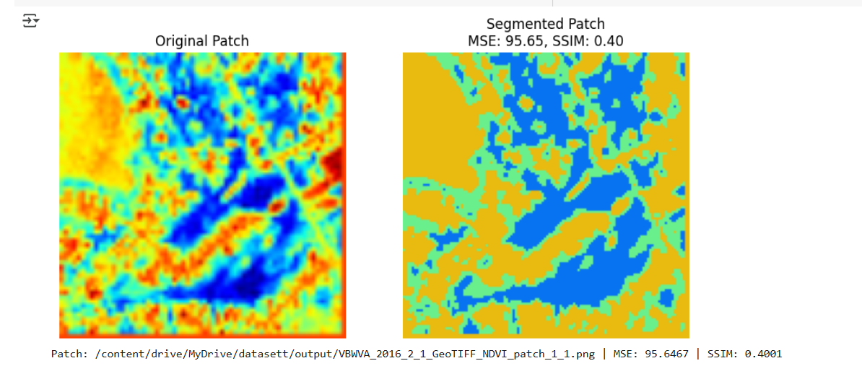

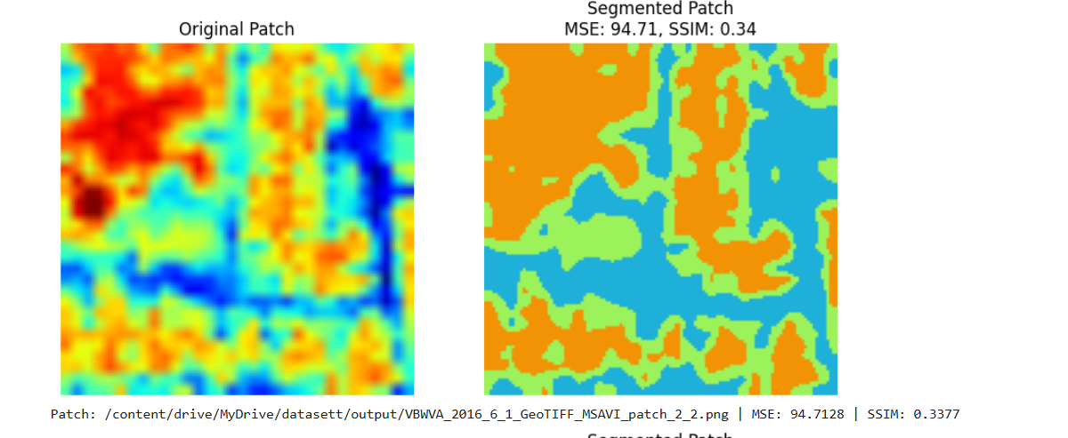

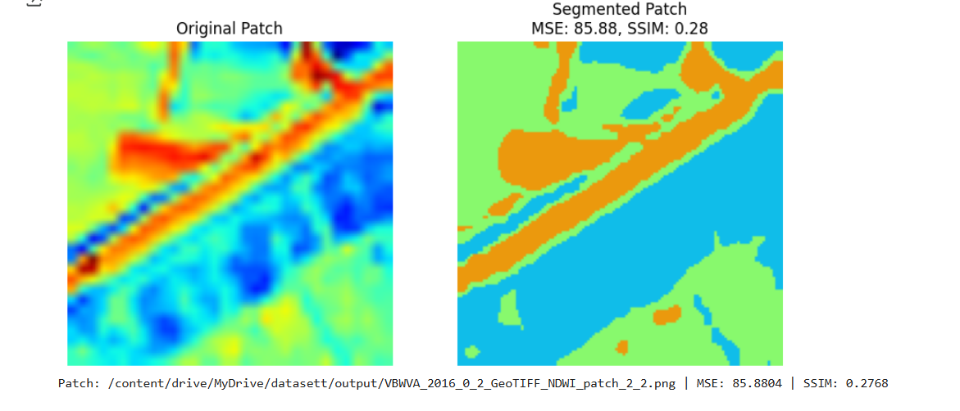

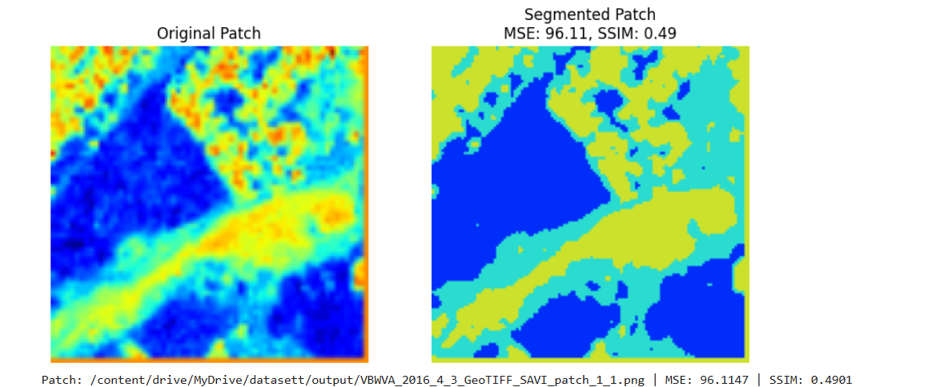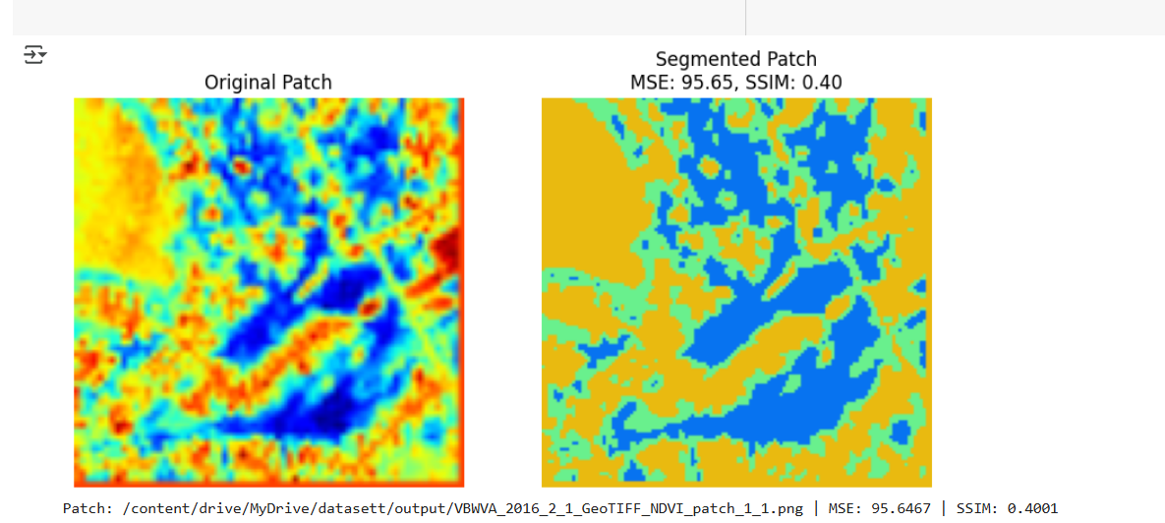

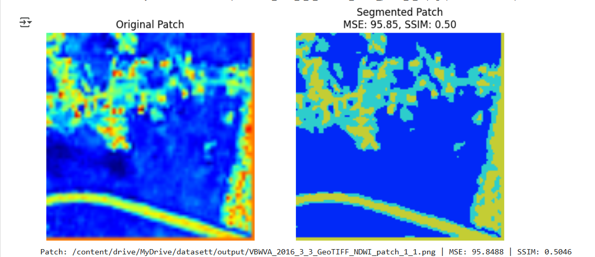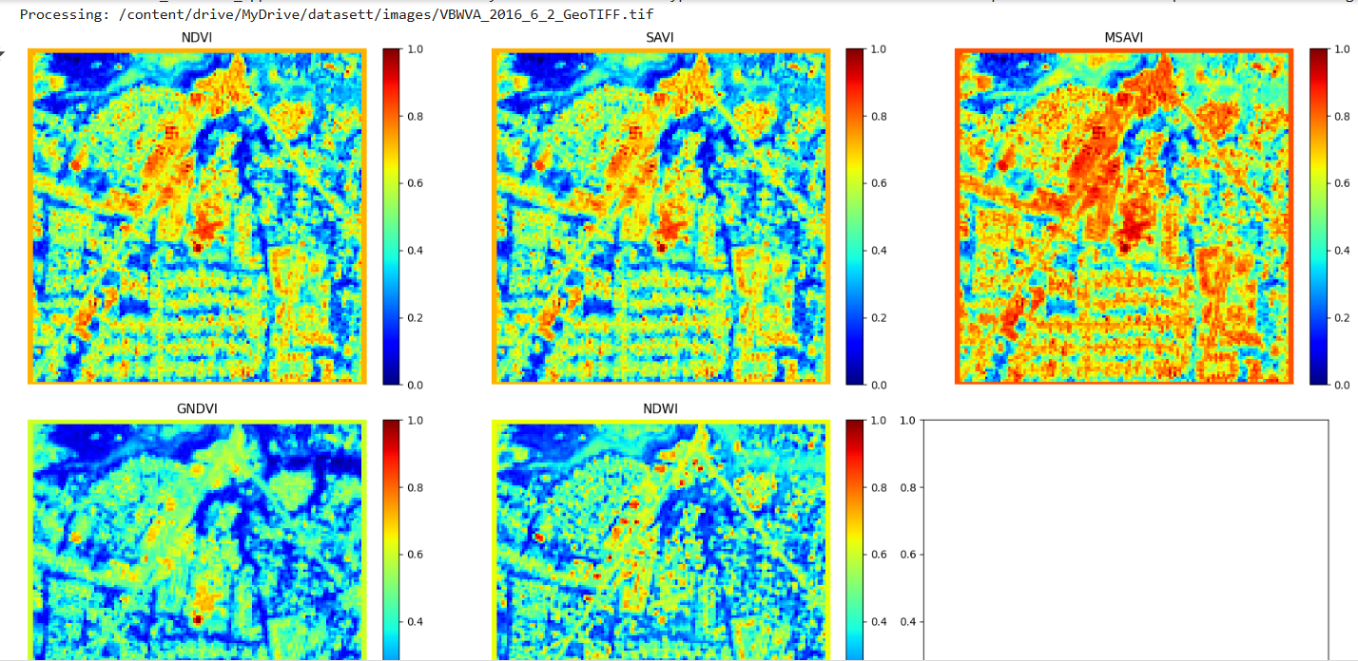

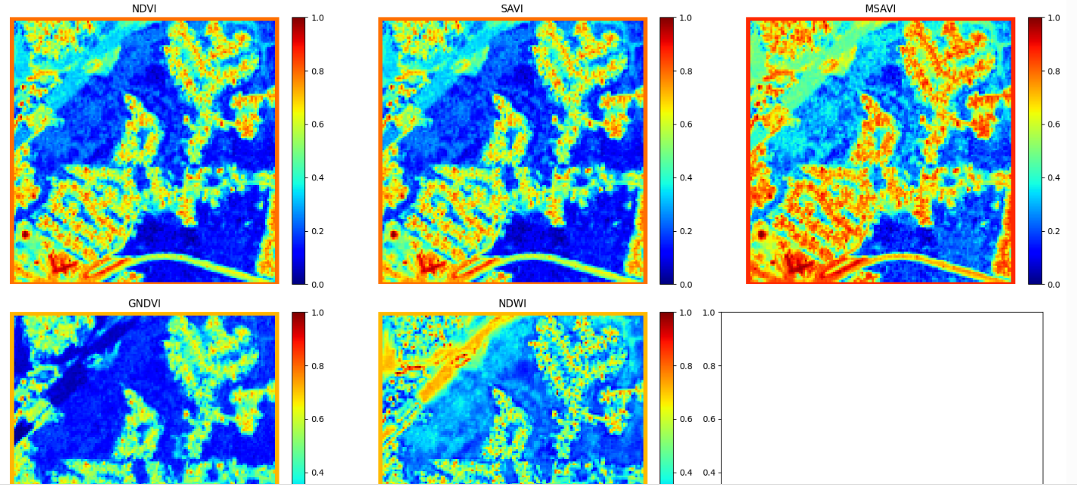

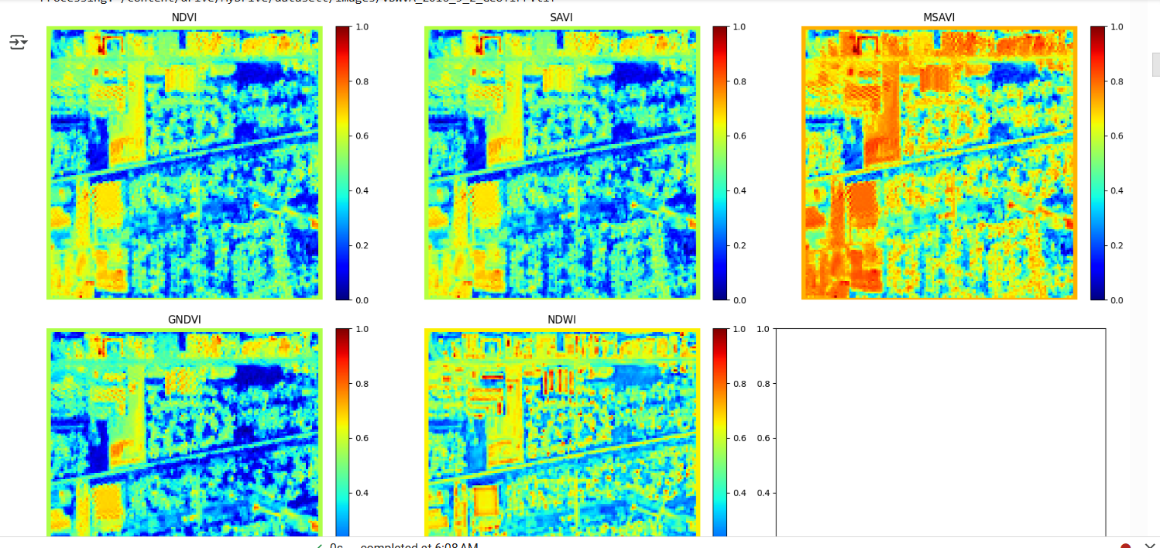

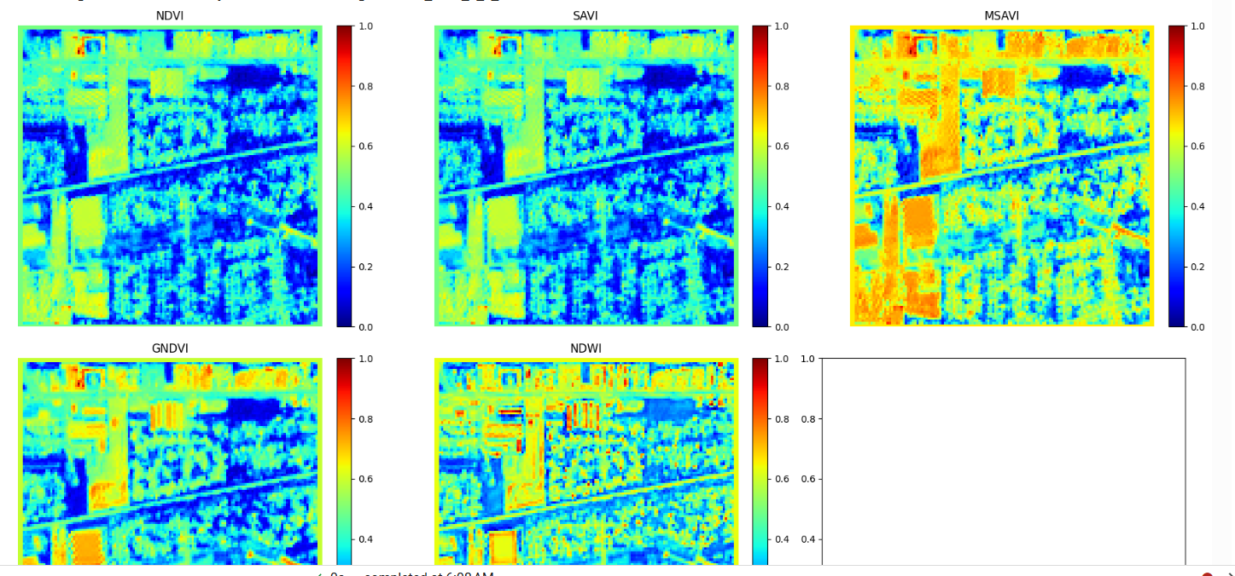

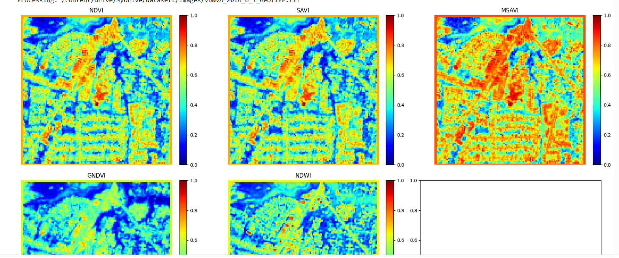

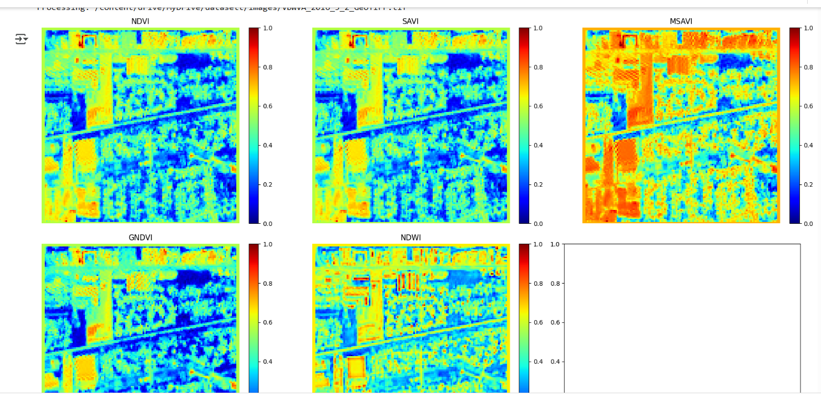

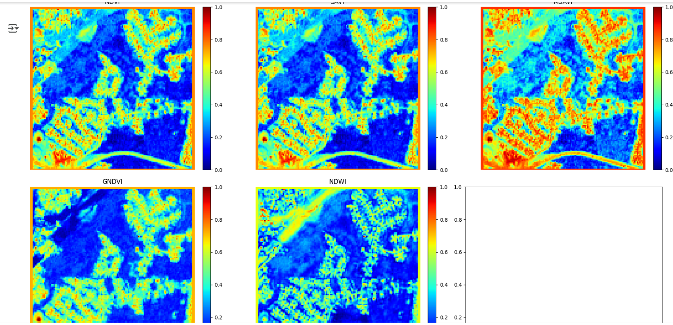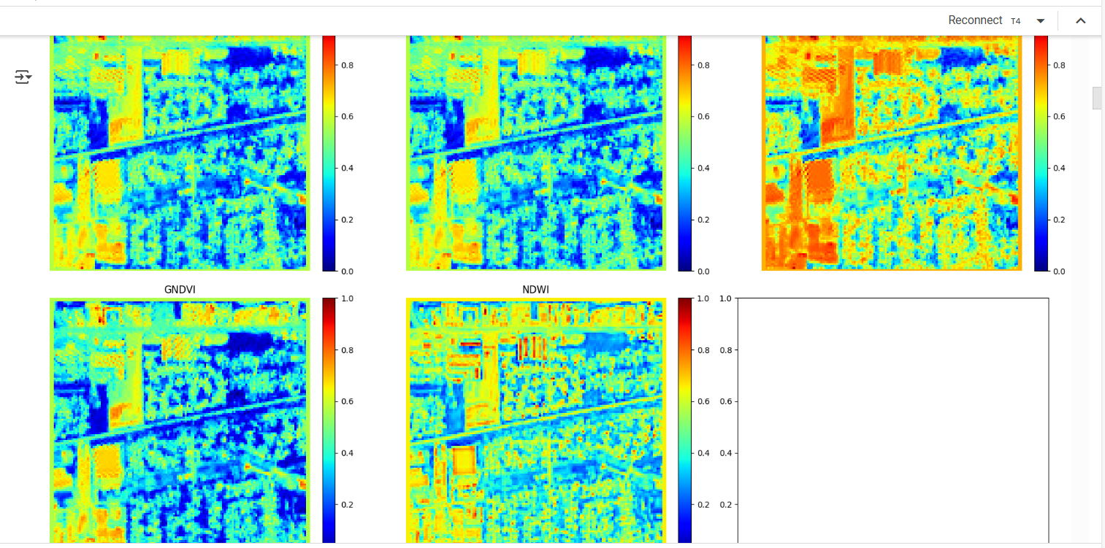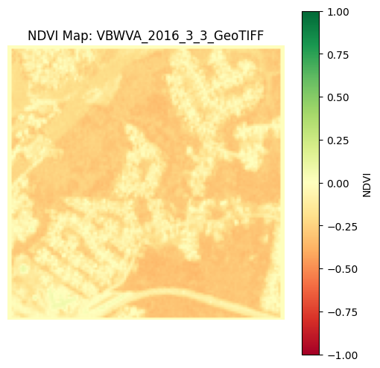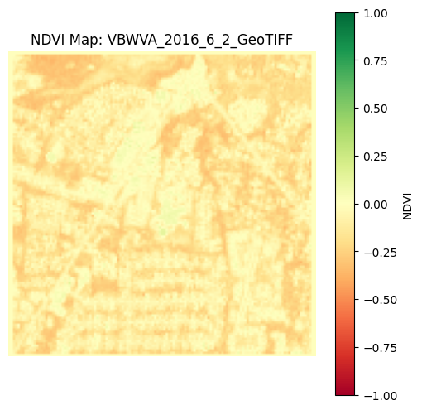

Steps of the Code Explained in English

This Python code processes GeoTIFF images to compute various vegetation indices (such as NDVI, SAVI, MSAVI, GNDVI, and NDWI) and saves the results as images. Below are the detailed steps:

1. Import Required Libraries

The code imports essential libraries:

os → To handle file operations

rasterio → To read GeoTIFF images

numpy → For numerical computations

matplotlib.pyplot → To display and save images

2. Define Function to Load GeoTIFF Images

Function: load_geotiff(file_path)

Opens the GeoTIFF file using rasterio

Reads all the bands (multi-spectral image layers)

Returns the image bands and metadata (profile)

3. Compute NDVI (Normalized Difference Vegetation Index)

Function: compute_ndvi(nir_band, red_band)

Uses the formula:

𝑁

𝐷

𝑉

𝐼

=

𝑁

𝐼

𝑅

−

𝑅

𝑒

𝑑

𝑁

𝐼

𝑅

+

𝑅

𝑒

𝑑

+

𝜖

NDVI=

NIR+Red+ϵ

NIR−Red

​

where NIR (Near-Infrared) and Red bands are extracted from the image.

The small value ε (epsilon = 1e-10) prevents division by zero.

4. Save and Display NDVI Map

Function: save_ndvi_map(ndvi, output_path, file_name)

Plots the NDVI image using a color scale (RdYlGn).

Saves the NDVI image in the output_path folder as a .png file.

Creates the folder if it doesn’t exist.

5. Process a Folder of GeoTIFF Images

Function: process_folder(input_folder, output_folder)

Iterates through all .tif or .tiff files in the given input_folder.

Loads the NIR (band 4) and Red (band 3) from each image.

Computes NDVI using compute_ndvi().

Saves the NDVI map using save_ndvi_map().

6. Compute Additional Vegetation Indices

Function: compute_vegetation_indices(nir, red, green, swir)

This function calculates multiple indices:

NDVI (Vegetation health)

SAVI (Soil Adjusted Vegetation Index)

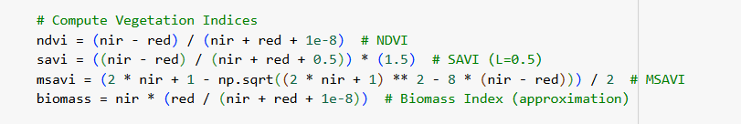​

7. Process TIFF Images and Compute Indices

Function: process_tiff_images(input_folder, output_folder)

Iterates through all TIFF images in input_folder.

Extracts NIR, Red, Green, and SWIR bands.

Calls compute_vegetation_indices() to calculate the indices.

Displays the indices using color maps (jet).

Saves each computed vegetation index as an image in output_folder.

8. Define Paths and Execute Processing

input_folder → Path where TIFF images are stored.

output_folder → Path where output images will be saved.

Calls process_folder() for NDVI and process_tiff_images() for multiple indices.

9. Install Missing Libraries (If Not Installed)

The command:

python

Copy code

!pip install rasterio numpy matplotlib

ensures the required packages are installed.

Final Output

NDVI and other vegetation index maps are saved as .png images in the output_folder.

Plots are displayed for visual inspection of results.

Step-by-Step Explanation of the Code

This code performs multiple tasks, including loading and displaying TIFF mask images, mounting Google Drive in Colab, computing vegetation indices from an image, and applying thresholding to distinguish vegetation from soil.

• **Step 1:** Displays TIFF masks with a colormap.

• **Step 2:** Mounts Google Drive for accessing data.

• **Step 3:**

* Computes vegetation indices.
* Creates a vegetation and soil mask.
* Displays vegetation indices and the original image.

